A weekly online presentation on Wednesday 20th of January on " The Academic Effects of VAK Learning Styles on EFL (English as a Foreign Language) Students to learn English Vocabulary” was presented by Dr. Parween Shawkat Kawthar at the English Department/ College of Education. This presentation was based on a published research paper under the same title. Below is the aim of the study and the presentation.
- The main purposes of the study are to investigate about how the linguistic levels of the students and their attitudes towards English language learning process influence their vocabulary learning styles through the practice of visual, auditory or kinesthetic (VAK) learning styles
- To find out if the preferred VAK learning styles affect the students’ abilities to increase the amount of the new vocabulary.
- Also the researcher aims to find out if the gender affects the selection of the VAK learning styles for learning vocabulary
- and exploring the correlation between EFL instruction and the preferred vocabulary learning styles so as to come up with teaching techniques that can support the quality of teaching and learning English as a foreign language
Both the presenter and the participants have contributed to the seminar by sharing their ideas to enrich the seminar. At the end of the seminar, there was a Q & A session for the participants to share more or ask any questions they had.
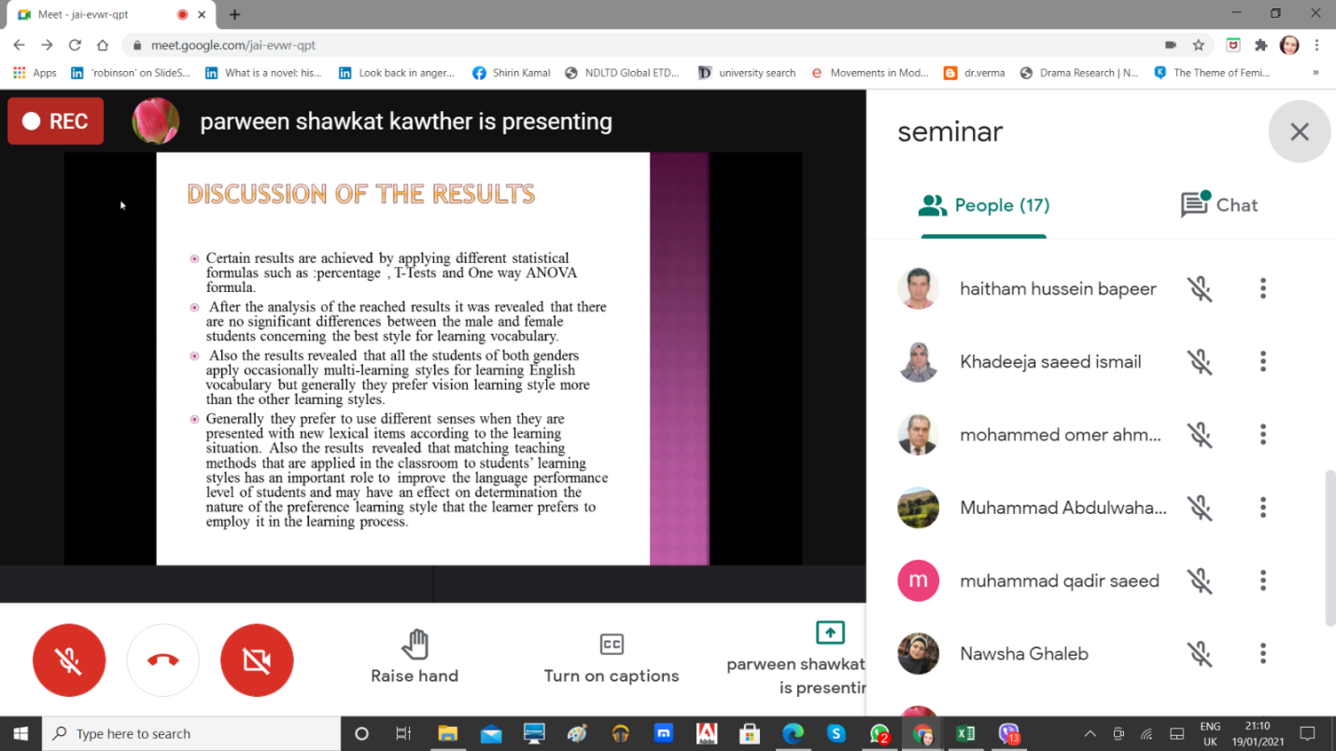

طفتوطؤى نامةى ماستةر لة بةشى زمانى ئينطليزى بة ناونيشانى (The Syntax and Semantics of Food/Fruit Idioms in English)
لة بة روارى (21/1/2021) رؤذى ثيَنج شةممة كاتذميَر (9) ى بةيانى طفتوطؤى نامةى ماستةرى قوتابى (تريفة ابراهيم مولود) لة هؤلَى (د. عبدالله حداد) لة كؤليَذى ثةروةردة – زانكؤى سةلاحةددين – هةوليَر ئةنجامدرا كة ئةندامانى ليَذنةى طفتوطؤ ثيَكهاتبوون لةم مامؤستاية بةرِيَزانةى خوارةوة:
- ث. د. محمد باسل العزاوي زانكؤى دهؤك سةرؤكى ليَذنة
- ث. ى.د. ئازاد حسن فتاح زانكؤى سليَمانى/ ك. زمان ئةندام
- د. رةوشةن ابراهيم طاهر زانكؤى سةلاحةددين/ ك. ثةروةدرة ئةندام
- ث.د.هيمداد عبدالقهار محمد زانكؤى سةلاحةددين / ك. ثةروةردةى بنةرةتى ئةندام و سةرثةرشتيار
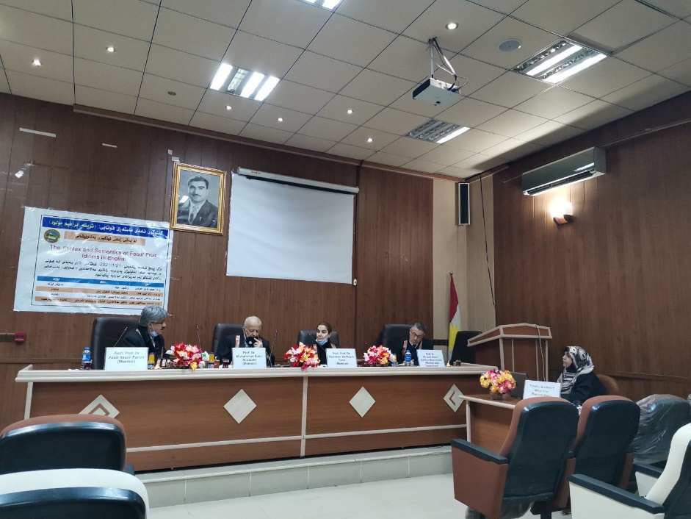

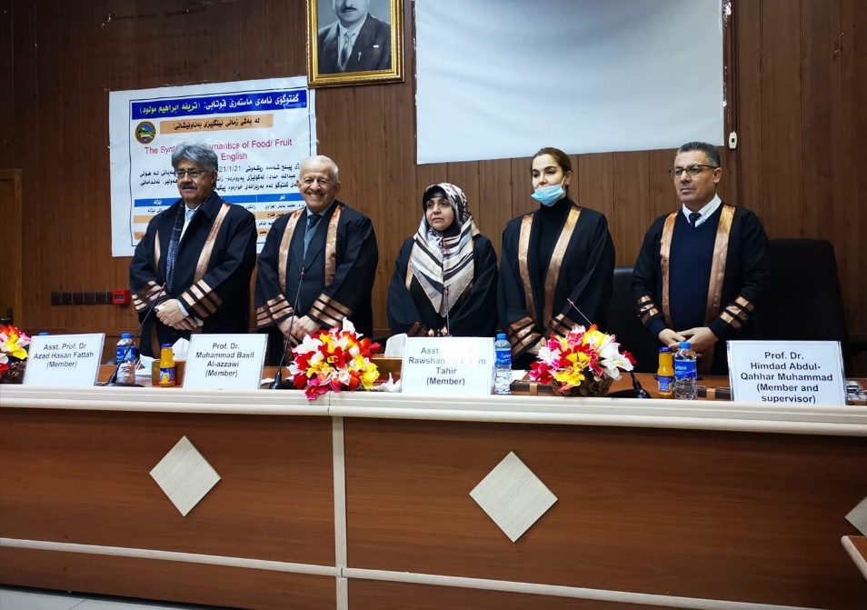

A weekly online presentation on Tuesday 26 of January on "Using Immersion Teaching Process to Develop EFL Learners’ Speaking skill" was presented by Dr. Arev Merza Astifo, which was based on her PhD project supervised by Dr. Hussen Ali Wali, at the English Department/ College of Education. Below is a brief summary of the project.
Speaking skill is one of the most significant skills because it is one of the means of conversation and communication with others. Thus, this paper aims at investigating the development of the students’ speaking skills by using the immersion teaching process, in addition to observing the authentic level of the students’ implementation in their speaking performance.
Both the presenter and the participants have contributed to the seminar by sharing their ideas to enrich the seminar. At the end of the seminar, there was a Q & A session for the participants to share more or ask any questions they had.
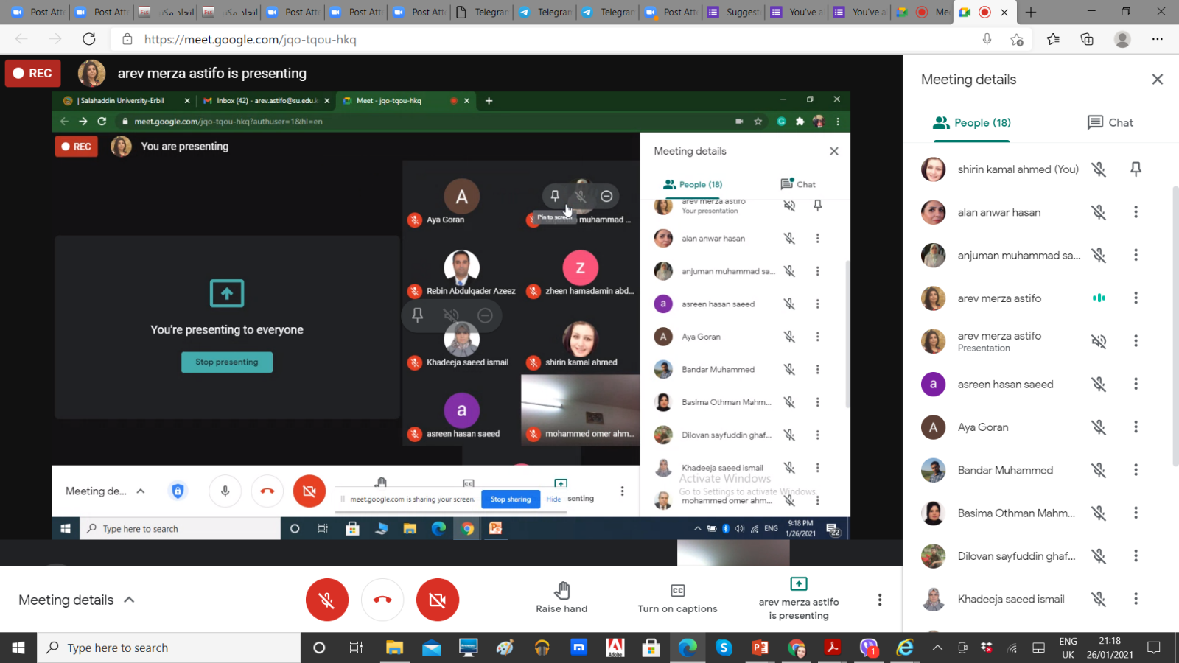
Keywords: Immersion teaching process, Project-based learning, Speaking skills

