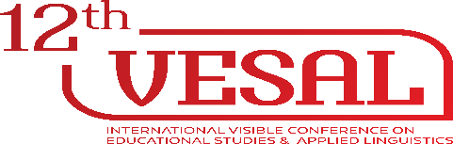
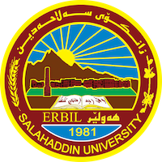
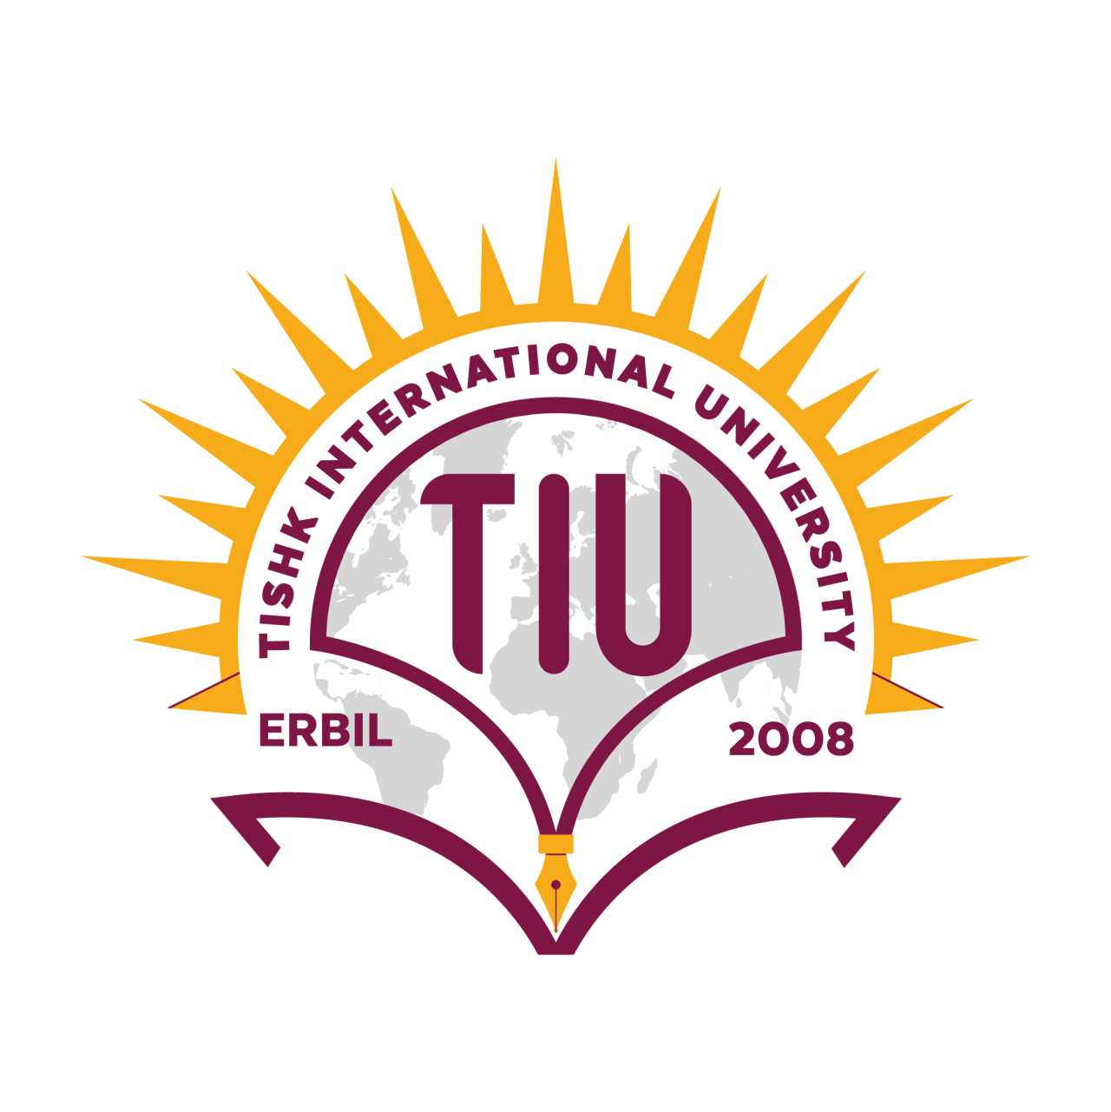

VESAL Conference: Educational Breakthrough to Success
In order to enable the knowledge and information accessible to everyone, Tishk International University, Faculty of Education holds its annual conference on Educational Sciences and Applied Linguistics in collaboration with university of Salahaddin, College of Education for the 12th year. The International Visible Conference aims to gather researchers, practitioners, educators, and scholars with interests in any fields of teaching at all levels from around the world. The VESAL 2022 conference is designed to attract the research communities to promote connections between theory and practice and explore different perspectives on the application of research findings into different practices. We kindly welcome scholars coming from the international and local regions as well as teachers and prospective teachers to Erbil, Iraq. The VESAL 2022 conference aims to contribute to the region and educators through international experts and researchers. The VESAL 2022 conference plans to remain open to educational studies, language teaching and/or language-education related topics broadly defined, looking more closely into the current dynamics in the world between old and new trends, local and global tendencies, progressive and conservative views, stabilization and destabilization patterns, national and global identities It is expected that VESAL 2022 conference will be a magnet for a significant number of front-ranking academics, professionals and policy makers working in the broad areas of Educational Environment.
To develop highly qualified individuals who will contribute to the future of the country by making utmost use of the knowledge gained in fields of science, technology and arts in the light of universal values; offer learning opportunities in the fields of research, education and service for the benefit of the wider community
Number of participants: 250 participants
Number of accepted abstracts: 55 abstracts
Keynote Speakers: 4 keynote Speakers
Keynote Speakers biography
Name of the Speaker: Prof. Mark LeTourneau
Job Title of the Speaker: Full professor in the Department of English at Weber State University, USA
Mark LeTourneau is a full professor in the Department of English at Weber State University, where he has taught since 1987. He teaches lower-division writing and literature, upper-division linguistics, and graduate courses in stylistics. His research is in Arabic morphology and in particular morphosyntax. As a teacher of writing and a second-language speaker of Arabic, he is personally and professionally invested in second-language learning and literacy. |  | 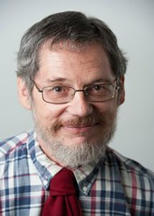
Name of the Speaker: Prof. Dr.Himdad A. Muhammad
Job Title of the Speaker: Staff member in English department, College of Basic Education, Salahaddin University-Erbil, Iraq
Dr. Himdad gained his PhD, MA in English Language & Linguistics from Salahaddin University Erbil/Iraq. He Has worked as university instructor since 1998 and taught undergraduate and post-graduate students in Salahaddin , Koya and Soran universities. He Supervised and participated in the discussion of over 60 Master thesis and PhD dissertations and viva committees. He is currently a staff member in English department, College of Basic Education, Salahaddin university-Erbil Member of the European Linguists Association, IATEFL He is a Chair of Kurdistan English Language Teachers Professional Network (KELTPN) and the founder & CEO of MegaMind Plus Academy | 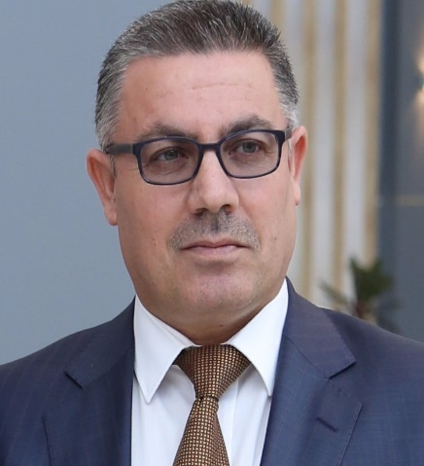
Name of the Speaker: Prof. Dr.Hedde Zeijlstra
Job Title of the Speaker: a university professor at the Seminar for English Philology at the Georg-August-University in Göttingen, Germany
Hedde Zeijlstra is a university professor at the Seminar for English Philology at the Georg-August-University in Göttingen, where he is the the speaker of the DFG-funded Research Training Group "Form meaning mismatches". His main interest is the relation between sentence meaning and form: how does the meaning of a sentence follow from its parts, and why are there so many different ways of expressing the same meaning across languages? Zeijlstra has held guest lecture appointments at, among others, Cambridge University, MIT and UCLA. Since 2017 he also has served as an associate editor of Natural Language & Linguistic Theory, and since 2018 as general editor of Linguistic Variation. In addition, he is a member of the editorial boards of Glossa, Linguistic Inquiry, the Journal of Linguistics, and Pragmatics & Semantics. | 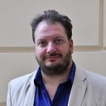
Name of the Speaker: Prof. Dr.Mahalingam Subbiah

Job Title of the Speaker: Professor in the Department of English at Weber State University, USA
Mahalingam Subbiah is a professor at Weber State University. He has been teaching undergraduate technical writing and literature courses and world literature courses at graduate level. He has been an active member presenting regularly at Rocky Mountain Modern Language Association conferences on literature, technical writing, and online pedagogy. He has managed to publish in Technical Communication; Technical Communication Quarterly; IEEE Professional Communication; Weber, The Contemporary West, and a chapter in Foundations for Teaching Technical Communication: Theory, Practice, and Program Design (Ablex). | 