Curriculum Viate
Personal Details :
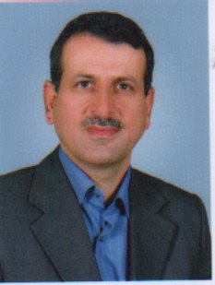
Name : Azad Arheed Aduleahab
Family Name: AL haweezi
Date and Place of Birth : 20 May 1964
Marital Sates : Married , two Children
Mobile Korek 0096407504470077 Asiacell 07705383700
Email : azadhawezi2014@gmail.com
Home Adress :Dream City No.265
Education :
M.Sc Urban & Regional planning - Baghdad University -1999- Iraq
B.Sc Surveying Engineer Department
Training Courses:
Computer programming salahaddin university 1999-English language ,Teaching Method Trainning
Qualification :
Speaking ,Reading, Writing 1-Kurdish 2- Arabic 3- English
Computer Programs : Windows ,word ,Excel ,AutoCad ,COGO .Civil3D.
Administration and Teaching :
1- Rifester of college of engineering
2- Head Assistant department Surveying department -College of engineering -Slahaddin University
3-Head department Surveying department -College of engineering -Slahaddin University
4-Lecturer in Civil department from 2000 to 2009- College of engineering -Slahaddin University
5-Lecturer in Surveying department from 2009 till now - College of engineering -Slahaddin University
Experience :
Many surveying works includ data collection and Layout of projects >
Equipment :
Automatic level ,Digital level ,Digital Theodolite , Total Station , G.P.S

